Mitchell Fontaine
CS-660
03/29/2026
8-2 Assignment: DSL Architecture and Control Flow Diagram
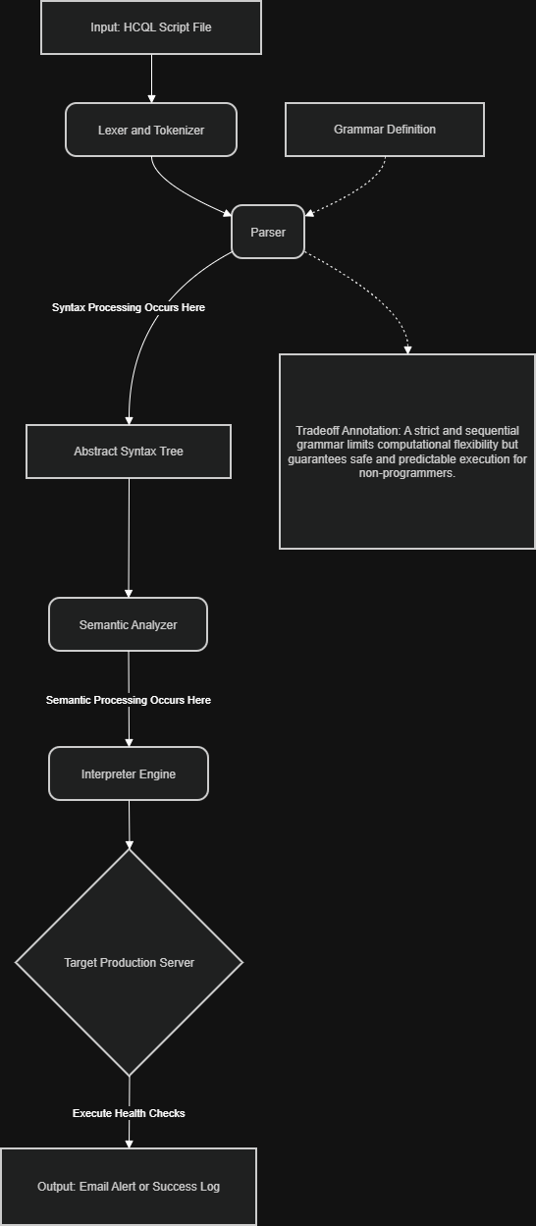
The architecture of the Health Check Query Language (HCQL) system follows a straightforward and linear pipeline designed for simplicity. Execution begins when an operator submits a plain-text script file to the core engine. This text is first processed by the lexer and parser components, which rely on a strictly defined grammar to understand the vocabulary of the language. Once the text is successfully parsed, the system constructs an Abstract Syntax Tree to represent the hierarchical structure of the commands. The interpreter then walks through this tree node by node to execute the corresponding underlying Python functions. These functions handle the actual secure shell connections and system commands on the remote target servers. Finally, the system aggregates the results to produce a final output of either a success confirmation or a triggered alert.
In HCQL, syntax and semantics are handled in distinct phases of the execution pipeline to ensure robust error catching. Syntax processing occurs exclusively within the parser component. The parser checks the incoming text against the formal grammar rules to ensure that keywords are spelled correctly and placed in the proper order. If a user forgets a required keyword or misplaces a quotation mark, the system halts immediately and returns a syntax error. Semantic processing takes place later in the pipeline, right before the interpreter executes the commands. During this phase, the system verifies the contextual meaning of the syntactically correct commands. For example, the semantic analyzer ensures that a provided CPU threshold is a valid mathematical integer rather than a random string of text.
A major design decision in this language architecture is the strict prioritization of operational safety over computational expressiveness. The diagram explicitly highlights this tradeoff by showing a highly linear control flow without any cyclic pathways or branching logic. General-purpose programming languages offer loops and conditional branching, which provide massive flexibility for complex tasks. However, this flexibility introduces significant risk when interacting directly with production server environments. By restricting the language to sequential and declarative statements, we eliminate the possibility of infinite loops or accidental destructive actions. This constraint ensures that domain experts can run health checks without needing a deep background in secure software engineering. Ultimately, the lack of expressiveness is exactly what makes the tool valuable for safe daily operations.
The provided diagram effectively communicates the high-level architecture of the language by mapping the complete journey from input to execution. It uses clear directional arrows to demonstrate the linear control flow, making the system easy to understand for stakeholders who may not be software engineers. By explicitly labeling the grammar, parser, and interpreter, the diagram breaks down the theoretical concepts of language design into concrete processing steps. The inclusion of an explicit annotation directly addresses the intentional limitations placed on the system design. This visual organization allows product managers and developers to quickly grasp how the underlying engine operates. Stakeholders can use this visual aid during design reviews to evaluate the feasibility and maintainability of the proposed language.

